Commission on Teacher Credentialing (CTC)  Policy Regarding Approved  Travel Expense Reimbursement  The Process:  In an effort to ensure prompt payment, please have your claim returned to the CTC within 14 days of the meeting date. The CTC provides a business reply envelope at the meeting for your use. Reimbursement of your claim should take approximately 60 business days. Your check will be sent directly to the address that is referenced on the claim.  Please note: a Current Payee Data Record (STD 204) must be on file (with your legal name) to process your claim.  Please follow the steps below to process your claim in an efficient manner:  - Complete the Travel Claim Information Sheet provided to you indicating all pertinent information (We need your car license plate if you are claiming any mileage).  - Please ONLY SIGN and DATE your Travel Expense Claim. The Travel Team Member will complete the rest of your Travel Expense Claim Form using the information that you provided on the Travel Claim Information Sheet.  - Enclose all applicable receipts. Be sure that the document indicates a zero b. (Copies cannot be accepted)  - A Payee Data Record (STD 204) is required for all first time volunteers OR if you have a change in your reporting status or address. | Commission Location:  1900 Capitol Avenue  Sacramento, CA 95811-4213  (916) 322-4974  Cal TRAVELSTORE:  (877) 454-8785 (Toll Free)  (916) 376-3989  PSD Travel Information:  psdtravel@ctc.ca.gov  (916) 327-2967  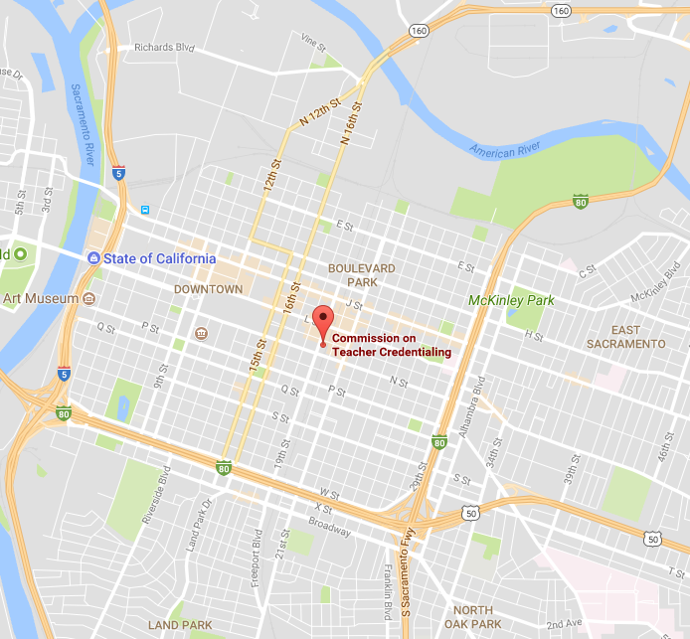  QUESTIONS?  You may contact the CTC Travel Team Member assigned to handle your claim for more detailed travel-related information.  *Reimbursement information subject to change  without notice. | State of California  - Commission on  - Teacher Credentialing  Travel Information Brochure  January 1, 2018

Current Per Diem Reimbursement Rates  Meal Reimbursement Rates:  All items claimed are to be for the ACTUAL AMOUNT OF EXPENSE up to the maximum allowed. Meals claimed on trips of less than 24 hours are taxable (only breakfast and dinner are authorized for travel less than 24 hours). Receipts are not required, however, but they should be retained for auditing purposes.  Event Cost Requirements  Breakfast Actual expense up to $7.00 Trip begins before 6:00 a.m.  Lunch Actual expense up to $11.00 Trip begins at or before 11:00 a.m.  Dinner Actual expense up to $23.00 Trip ends after 7:00 p.m.  Incidentals/ Tips *See definition in next column Actual expense up to $5.00/day Only permitted on trips over 24 hours  Lodging Reimbursement Rates for Volunteers:  All California Counties except those listed below Actual expense up to $90 per night, plus tax  Napa, Riverside & Sacramento Counties Actual expense up to $95 per night, plus tax  Los Angeles, Orange, Ventura Counties & Edwards AFB (excluding the City of Santa Monica) Actual expense up to $120 per night, plus tax  Alameda, San Mateo & Santa Clara Counties Actual expense up to $140 per night, plus tax  The City of Santa Monica Actual expense up to $150 per night, plus tax  Marin County Actual expense up to $110 per night plus tax  San Diego & Monterey Counties Actual expense up to $125 per night plus tax  San Francisco County Actual expense up to $250 per night, plus tax  Please note: The Traveler MUST live a minimum of 50 miles from the meeting destination to qualify for lodging reimbursement.  Mileage Reimbursement Rates:  Reimbursement for mileage is at a rate of .545 cents per mile. BE SURE TO INCLUDE YOUR LICENSE PLATE NUMBER OR YOU WILL NOT BE REIMBURSED FOR MILEAGE. | *DEFINITION OF INCIDENTALS/TIPS: Effective February 1, 2015, CalHR updated the State’s definition of items that may be claimed as an incidental to ensure the State is in compliance with recent standards set by the IRS. “The term ‘incidental expenses’ means fees and tips given to porters, baggage carriers, hotel staff, and staff on ships.”  NO OTHER ITEMS MAY BE CLAIMED AS AN INCIDENTAL.  Air Fare:  Please contact the Travel Store at 1 (877) 454-8785 regarding all CTC-related Travel. Individuals must be pre-approved to travel prior to being ticketed. CTC is charged a service fee every time a ticket is issued, so please make changes sparingly. There is a free “24 hour check-In” available, CTC is not authorized to pay for the “Early Bird check in.”  Rental Cars:  Renting cars is not encouraged and volunteers MUST be pre-approved by CTC authorized staff (i.e., Executive Director, Division Director, Administrator) to be reimbursed for rental car fees. If approved, the State authorized vendors are:  - Enterprise Rent-a-Car  - AVIS  Refueling Rental Cars:  Refueling rental cars must be done prior to returning the vehicle to the rental agency.  Please Note:  - The Collision Damage Waiver (CDW) and the Personal Accident Insurance (PAI) should be declined whenever a contract rental car is used.  - If one or more of the following items causes loss or damage, the volunteer is personally responsible and liable.  - Willful or wanton misconduct on the part of the driver.  - Obtaining the vehicle through fraud or misrepresentation.  - Operation of the vehicle by a driver who contributed to the vehicle damage while such person was (and has been adjudged by the courts to have been) under the influence of alcohol or any drug.  - Use of the vehicle for any intentionally illegal purposes.  - Use or permitting the vehicle to carry unauthorized passengers or property for hire.  - Use or permitting the vehicle in a test, race, or contest.  - Operation of the vehicle by a person other than an authorized driver. | Parking Reimbursement: The State is only authorized to reimburse parking costs for the LEAST EXPENSIVE RATE AVAILABLE (i.e., economy parking or self-parking). If the more expensive parking is chosen, full reimbursement may not be authorized.  Parking at the Commission:  There is two-hour street parking around the Commission Building, but there are posted “no parking” days for street-cleaning (tickets are expensive). Metered parking is available on 21st Street between Capitol and L Streets, and L Street between 20th and 21st Streets. Additionally, there is a parking lot located on 21st and Capitol. Receipts are not required for reimbursement for parking under $10.00).  General Information:  For more information regarding the City of Sacramento, contact the following:  - Sacramento Convention and Visitors Bureau (916) 808-7777  - www.visitsacramento.com  - www.cityofsacramento.org/visitors/visitorsbureau  Shuttles and Taxis:  (916) 444-2222 – Yellow Cab  (800) 258-3826 – Super Shuttle  (916) 444-0000 – Sac Town Taxi & Shuttle  (916) 234-6884 – Sacramento Airport Shuttle  (916) 604-1111 – Sacramento Airport Taxi  Final Check List  - Sign and Date Section 15 of the Travel Expense Claim in BLUE or Black INK  - Include all requested information on the Travel Claim Information Sheet  - Include all applicable original receipts  - Include a completed Payee Data Record (STD 204)  - Return your claim to the Commission within 14 days.

