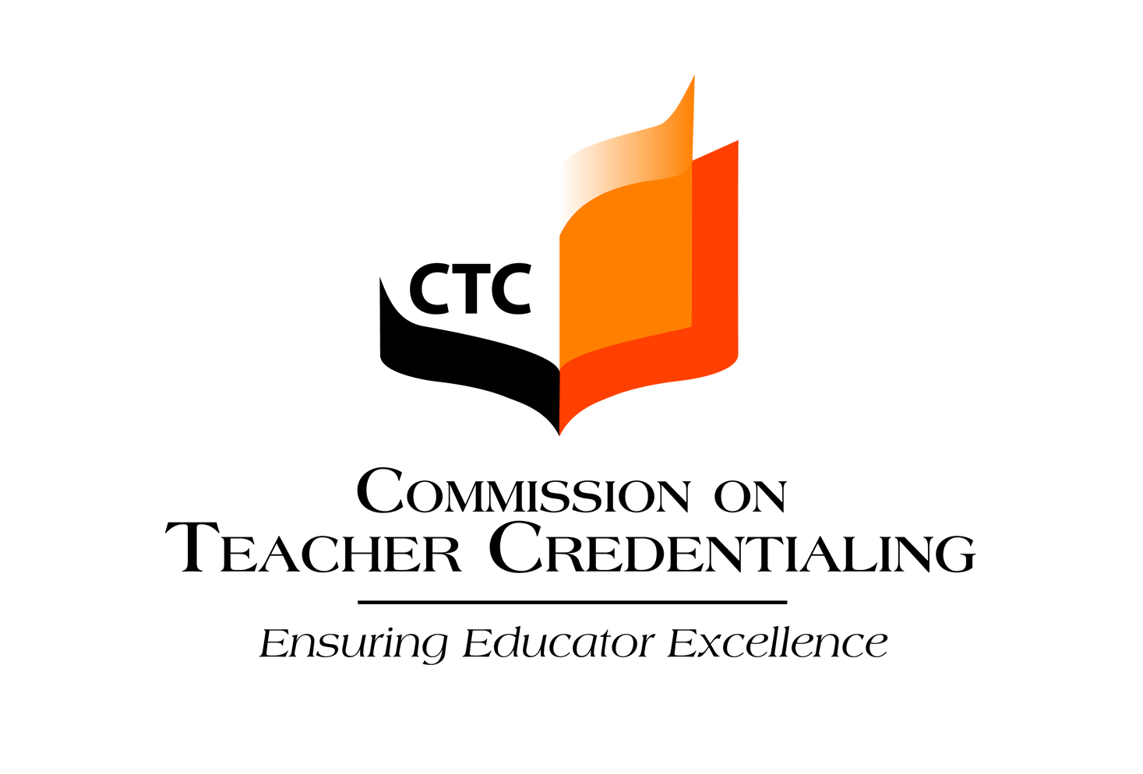
Timeline - Preparing for an Accreditation Site Visit

Provided below are activities that must take place in preparation for an accreditation site visit. The institution, with the assigned CTC Consultant, will identify dates for the institution’s submission of documentation prior to the visit.

 | Activity | Time before the Site Visit (SV)
 | CTC consultant is assigned to the program sponsor | 7-10 months prior to SV
 | A Pre-Visit phone conference is held | 7-10 months prior to the SV
** | Preconditions Document is due to the CTC  The Preconditions Document has three parts: contextual information about the institution, responses to Preconditions for each credential offered, matrix of approved programs | 6-12 months prior to the SV
 | Team Lead is assigned and the program sponsor is notified | 6-10 months prior to the SV
** | Site Visit Documentation is organized and includes the Common Standards narrative with hyperlinks to appropriate documentation | 3-8 months prior to the SV
 | Logistics: discuss and confirm details of the team stay; lodging, meals, parking, reimbursement, etc. The Commission Travel Brochure provides the contract parameters for the accreditation visit and the state per diem restrictions for lodging and meals. | 3-6 months prior to the SV
 | Two month-out Pre-visit: Team Lead and Consultant spend one day with the program sponsor reviewing all arrangements; all SV documentation is available; pre-final draft interview schedule reviewed. | 2-3 months prior to the SV
** | Site Visit Documentation is sent to all team members, Team Lead and CTC consultant(s) or posted on accreditation web page | 2 months prior to the SV
** | Final interview schedule is shared with the team lead and the Consultant(s) | 2 weeks prior to the SV
 | Site Visit | Site Visit
** | Finalization of Draft Site Visit Report | 2 weeks after the SV
 | Presentation to the COA | 1-3 months after the SV
** Information is due to CTC for this activity

